

LPU NAVIGATOR USING AI

SUBMITTED TO – MRS. ISHATPREET KAUR

SUBMITTED BY-
(Roll no. 58, 11811857) PRAKASH
(Roll no. 59, 11804851) JASSICA
(Roll no. 60, 11805927) ANKIT PATEL

INTRODUCTION
Navigators have high potential in several applications. These include automatic driving with guidance for the blind and disabled, explorations of dangerous or unknown regions. Current research and development of navigators have attracted the attention of researchers in the areas of engineering, biology, mining, industrial and others. Autonomous navigators are intelligent agents which can perform desired tasks in various (known and unknown) environments without continuous human control. A navigator should able to identify features, detect obstacles, patterns and target, learn from experience, find a path and build maps, and navigate. These abilities of navigator require the simultaneous application of many research disciplines such as Engineering and their application. To satisfy this goal navigator research has increasingly incorporated artificial intelligence enabling the machines to mimic living beings. Path analysis and planning is another exciting challenge. An autonomous navigator must be able to learn its environment and programming itself without assistance. It consists on finding a route to its target destination. Path analysis and planning becomes more difficult when some static as well as dynamic obstacles are added to the environment. In accomplishment such familiar tasks, humans use observations of time, distance, speed, shape, and other aspects of physical and mental things.
Navigation is a field of study that efforts on the process of monitoring and controlling the movement of a user from one place to another. This navigation field includes different general categories i.e. marine navigation, land navigation, aeronautic navigation, and space navigation. It is also the term to use for the specialized knowledge used by navigators to carry out navigation tasks. To locating the navigator position compared to known locations involves different navigational techniques.
AIM AND OBJECTIVES
The overall aim of this research is to explore the application of artificial intelligence techniques to navigate. In this, field navigation and simulated techniques have been used to solve navigation problems. The development of techniques for autonomous navigation operation constitutes one of the major trends in the current research and practice in modern era. The goal of autonomous navigator is to build and control physical systems which can navigate purposefully and without human intervention in real-world environments which have not been specifically engineered for the robot. This includes the kinematics, perception, cognition, sensor fusion, path analysis, path planning and navigation. The following behaviors are required during navigation:
1. map and plot position using python.
2.target searching.
2. Shortest path evaluation from the given graph by marking and adding edges.

Our goal was to have our navigator transmit GPS data (as well as other sensor data) over RF, to a base station, and graphically display position and altitude on a map. Our base station is a radio receiver connected to my laptop over a serial to USB connection. However, instead of using radios, we will use a GPS tethered to our computer over USB, as a proof of concept.We wanted the position of the balloon plotted on our own map, so that we could actively track, without the need for internet or paper maps. The program will plot positions on a map of our choice.

Hardware Requirements

1. Python interpretor version 3+
2. 5V FTDI Basic
3. EM-406 GPS module with Breakout Board (or any NMEA capable GPS)
4. laptop

Methodology , discription and testing of equipments

1. Python interpretor version 3 and above
Python is an open source interpreted programming language.The program we write isn't compiled as a whole, into machine code, rather each line of the program is sequentially fed into something called a Python interpreter. Once we get the Python interpreter installed, we can write scripts using any text editor. Our program is run by simply calling our Python script and, line by line, our code is fed into the interpreter. If our code has a mistake, the interpreter will stop at that line and give you an error code, along with the line number of the error.

2. Testing and running a python script

Running a Python Script
Once we invoke the Python interpreter, we can now run a simple test script.
For example, here is a simple script that will print 'test' continuously.

# simple script
def test():
print "test"
while 1:
test()

The first line is a comment (text that isn't executed) and can be created by using a # .
The second line is a function definition named test().
The third line is spaced 4 times and is the function body, which just prints "test" to the command window.
The third line is where the code starts in a while loop, running the test() function.

3.Python serial loopback /making of a program that can transmit and receive data
It requires using an FTDI Basic or any other serial COM port device.
Simply, connecting the TX pin to the RX pin with a wire to form a loopback. Anything that gets sent out of the serial port transmit pin gets bounced back to the receive pin. This test proves our serial device works and that we can send and receive data.

Now, pluging our FTDI Basic into our computer and find our COM port number. We can see a list of available ports by typing this:

python -m serial.tools.list_ports

Now the piece of code below

import serial

#####Global Variables######################################
#be sure to declare the variable as 'global var' in the fxn
ser = 0

#####FUNCTIONS#############################################
#initialize serial connection
def init_serial():
COMNUM = 9 #set you COM port # here
global ser #must be declared in each fxn used
ser = serial.Serial()
ser.baudrate = 9600
ser.port = COMNUM - 1 #starts at 0, so subtract 1
#ser.port = '/dev/ttyUSB0' #uncomment for linux

#ww must specify a timeout (in seconds) so that the
# serial port doesn't hang
ser.timeout = 1
ser.open() #open the serial port

# print port open or closed
if ser.isOpen():
print 'Open: ' + ser.portstr
#####SETUP################################################
#this is a good spot to run our initializations
init_serial()

#####MAIN LOOP############################################
while 1:
#prints what is sent in on the serial port
temp = raw_input('Type what you want to send, hit enter:\n\r')
ser.write(temp) #write to the serial port
bytes = ser.readline() #reads in bytes followed by a newline
print 'You sent: ' + bytes #print to the console
break #jump out of loop
#hit ctr-c to close python window
First thing we need to do before running this code is to change the COM port number to the one that is attached to our FTDI. The COMNUM variable in the first few lines is where we enter our COM port number.

Now, if we want to send data over the serial port, use:

ser.write(your_data)

our_data can be one byte or multiple bytes.
If we want to receive data over the serial port, use:
your_data = ser.readline()

The readline() function will read in a series of bytes terminated with a new line character (i.e. typing something then hitting enter on your keyboard). This works great with GPS, because each GPS NMEA sentence is terminated with a newline. For more information on how to use pyserial, look here.

We might realize that there are three communication channels being used:
ser.write - writes or transmitts data out of the serial port
ser.read - reads or receives data from the serial port
print - prints to the console window
Just be aware that 'print' does not mean print out to the serial port, it prints to the console window.

Now try to run the script by typing (remember we need to be working out of the directory of the pythonGPS.py file):

python pythonGPS.py

This script will open a port and display the port number, then wait for our to enter a string followed by the enter key. If the loopback was successful, we should see what we sent and the program should end with a Python prompt >>>.

After successful completion we have just made a very simple serial terminal program that can transmit and receive data!

4. Reading the map

Reading a GPS and plot position with Python
Now that we know how to run a python script and open a serial port, there are many things we can do to create computer applications that communicate with embedded hardware. Now we are going to make a program that reads GPS data over a serial port, saves the data to a txt file; then the data is read from the txt file, parsed, and plotted on a map.

There are a few steps that need to be followed in order for this program to work.We need to install the modules in the order below.

Install modules

pyserial (should already be installed from above)
numpy
matplotlib
pynmea
The above process worked for our window 10 machine.

Once we have all of these modules installed without errors, we can run the given program with a pre-loaded map and GPS NMEA data to see how it works:
5.Selecting a Map
Any map image will work, But here we are using Map image of LPU and all we need to know are the bottom left and top right coordinates of the image. The map we used is a screen shot from Google Earth. We set placemarks at each corner and noted the latitude and longitude of each corner.
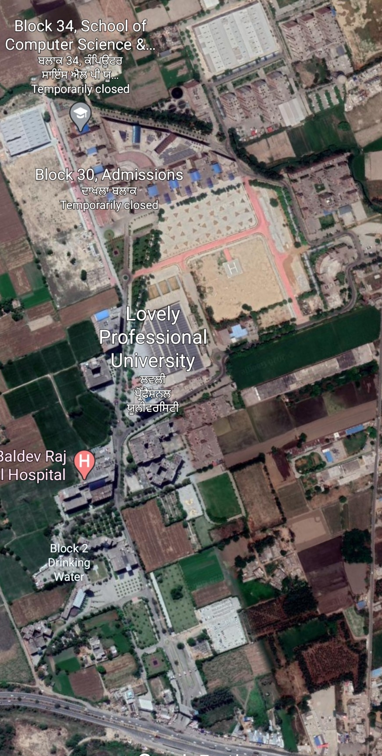

Upper right corner :- 31°15'04"N 75°41'58"E
Upper left corner :- 31°14'58"N 75°42'21"E
Lower right corner :- 31°15'41"N 75°42'19"E
Lower left corner :- 31°15'32"N 75°42'37"E

The more precisely we crop and mark the location of the corner the more accurate the navigator will work.

6.Hardware setup
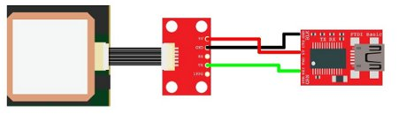
The hardware for this example includes a FTDI Basic and any NMEA capable GPS unit.

EM-406 GPS connected to a FTDI Basic

For the connections, all we need to do is power the GPS with the FTDI basic (3.3V or 5V and GND), then connect the TX pin of the GPS to the RX pin on the FTDI Basic.
It is probably best to allow the GPS to get a lock by leaving it powered for a few minutes before running the program. If the GPS doesn't have a lock when we run the program, the maps will not be generated and we will see the raw NMEA data streaming in the console window. If we don't have a GPS connected and we try to run the program, we will get out-of-bound errors from the parsing. We can verify your GPS is working correctly by opening a serial terminal program.

7.Run the program
Here we get the gps device connected , and make the program folder ready with every resources including map image and the main program.

The nmea.txt file will automatically be created if we have our GPS connected. If we don't have a GPS connected and we already have NMEA sentences to be displayed,than we need to create a file called 'nmea.txt' and drop the data into the file.

Now open maps.py, we will need to edit some variables, so that our map image will scale correctly.

We will edit these variables specific to the top right and bottom left corners of your map.
TRX = - 31.1504 #top right longitude
TRY = 75.4158 #top right latitude
BLX = -31.1532 #bottom left longitude
BLY = 75.4237 #bottom left latitude
Now we will run the program by typing:

python gpsmap.py
The program starts by getting some information from the user.
We will select to either run the program with a GPS device connected or we can load our own GPS NMEA sentences into a file called nmea.txt. Since we have our GPS connected, we will select our COM port and be presented with two mapping options: a position map......or an altitude map.

Once we open the serial port to our GPS, the nmea.txt file will automatically be created and raw GPS NMEA data, specifically GPGGA sentences, will be logged in a private thread. When we make a map selection, the nmea.txt file is copied into a file called temp.txt, which is parsed for latitude and longitude (or altitude). The temp.txt file is created to parse the data so that we don't corrupt or happen to change the main nmea.txt log file.
The maps are generated in their own windows with options to save, zoom, and hover our mouse over points to get fine grain x,y coordinates.
Also, the maps don't refresh automatically, so as our GPS logs data, we will need to close the map window and run the map generation commands to get new data. If we close the entire Python program, the logging to nmea.txt halts.

This program isn't perfect. Due to lockdown and unavailablility of resources we were unable to test its perfectly or achieve its objectives completely.
Thank you for evaluating .

